**Activity 1**

Bermundo, Carl Vincent Dayo 0118 - 2644

BSIT – 4A (WAM) Charles Alfred Cruz

1. **Line**

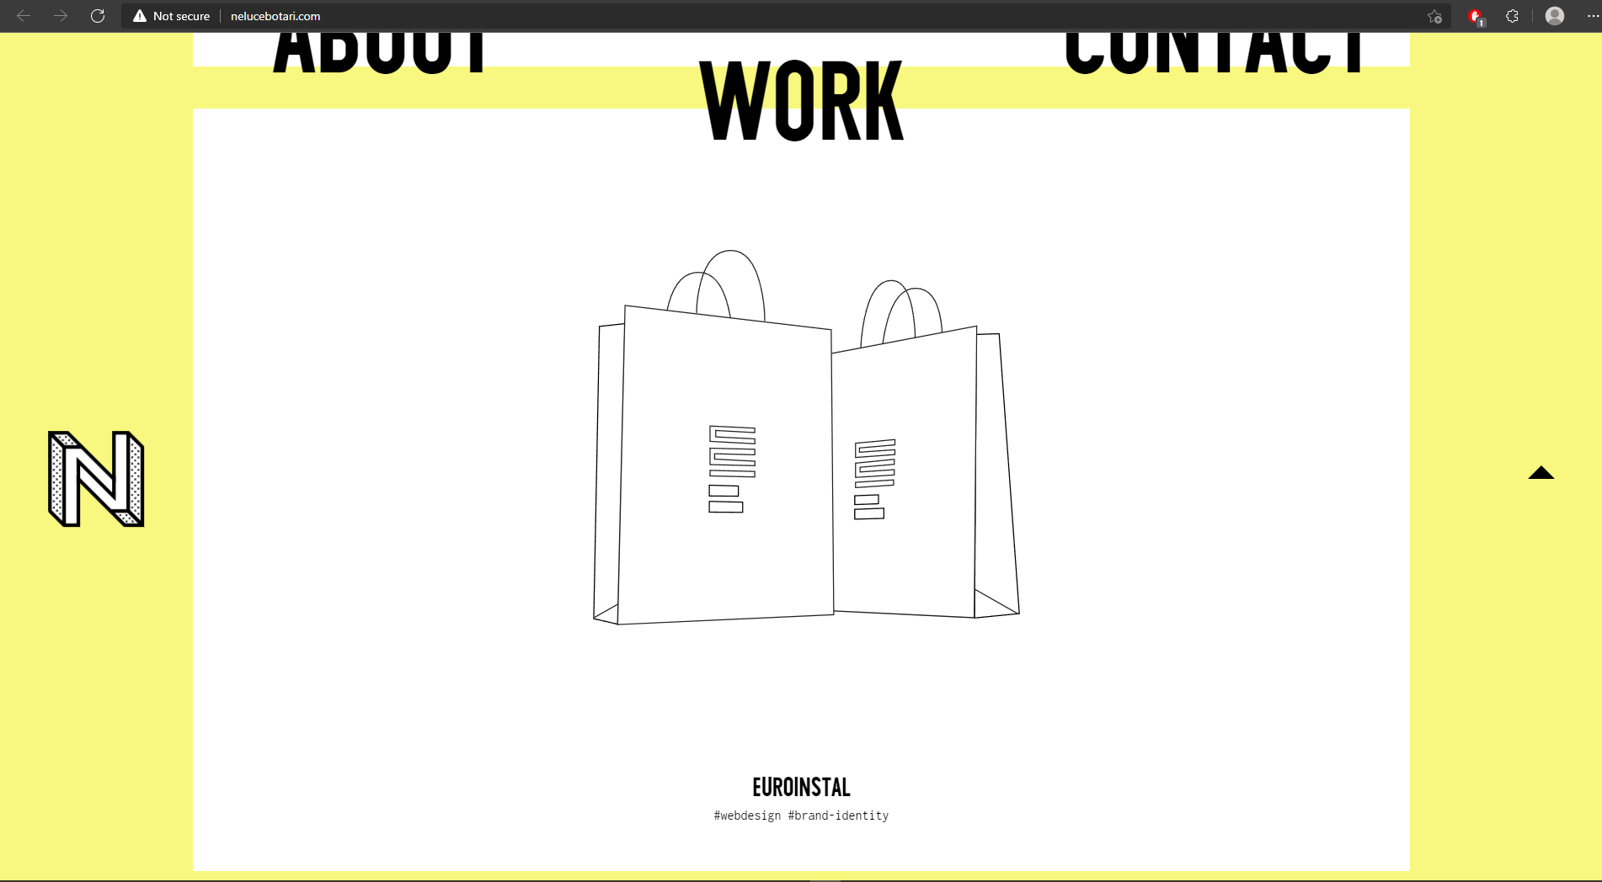

**Explanation:** This website is a personal website to showcase the owner’s skills and experience. The designer used lines as an outline for the objects and items included in their page like bags, cars, and also for their icons. When the user hovers over the items, it will show their original picture. By doing this, the user will interact more with the website.

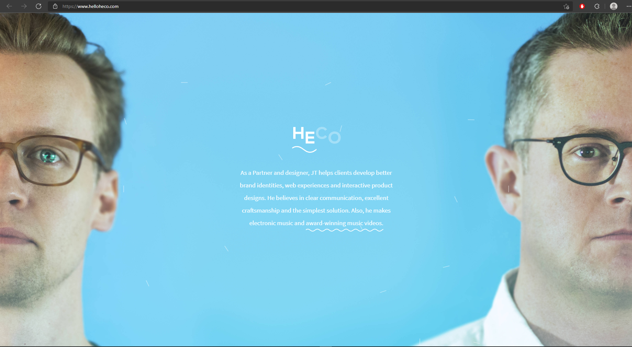

**Explanation:** This website is used to advertise and promote the services they offer which are creating dynamic brands for new companies. In the picture above, they used curved lines to emphasize the word “he” as the designer is a male and they also put wavy lines under his achievements. By doing this, they will focus more on the things with the lines.

1. **Color**

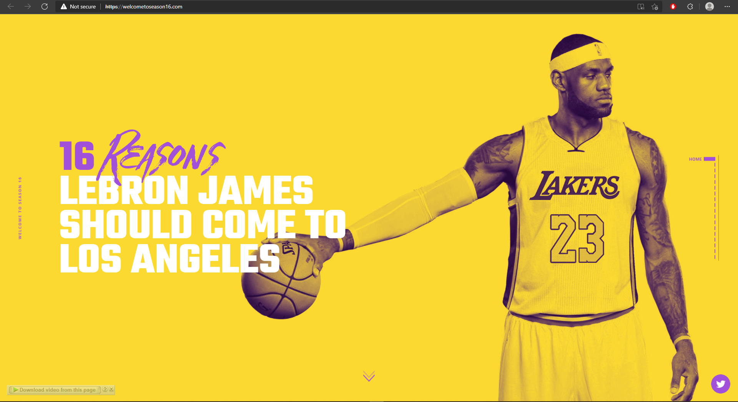

**Explanation:** This website is all about the NBA team Los Angeles Lakers. The main colors for Lakers are violet and yellow which is an example of complementary color. They also used these colors because they represent Lakers. Imagine using different colors, like orange and black, the viewers will be confused as they are not the colors of the team.

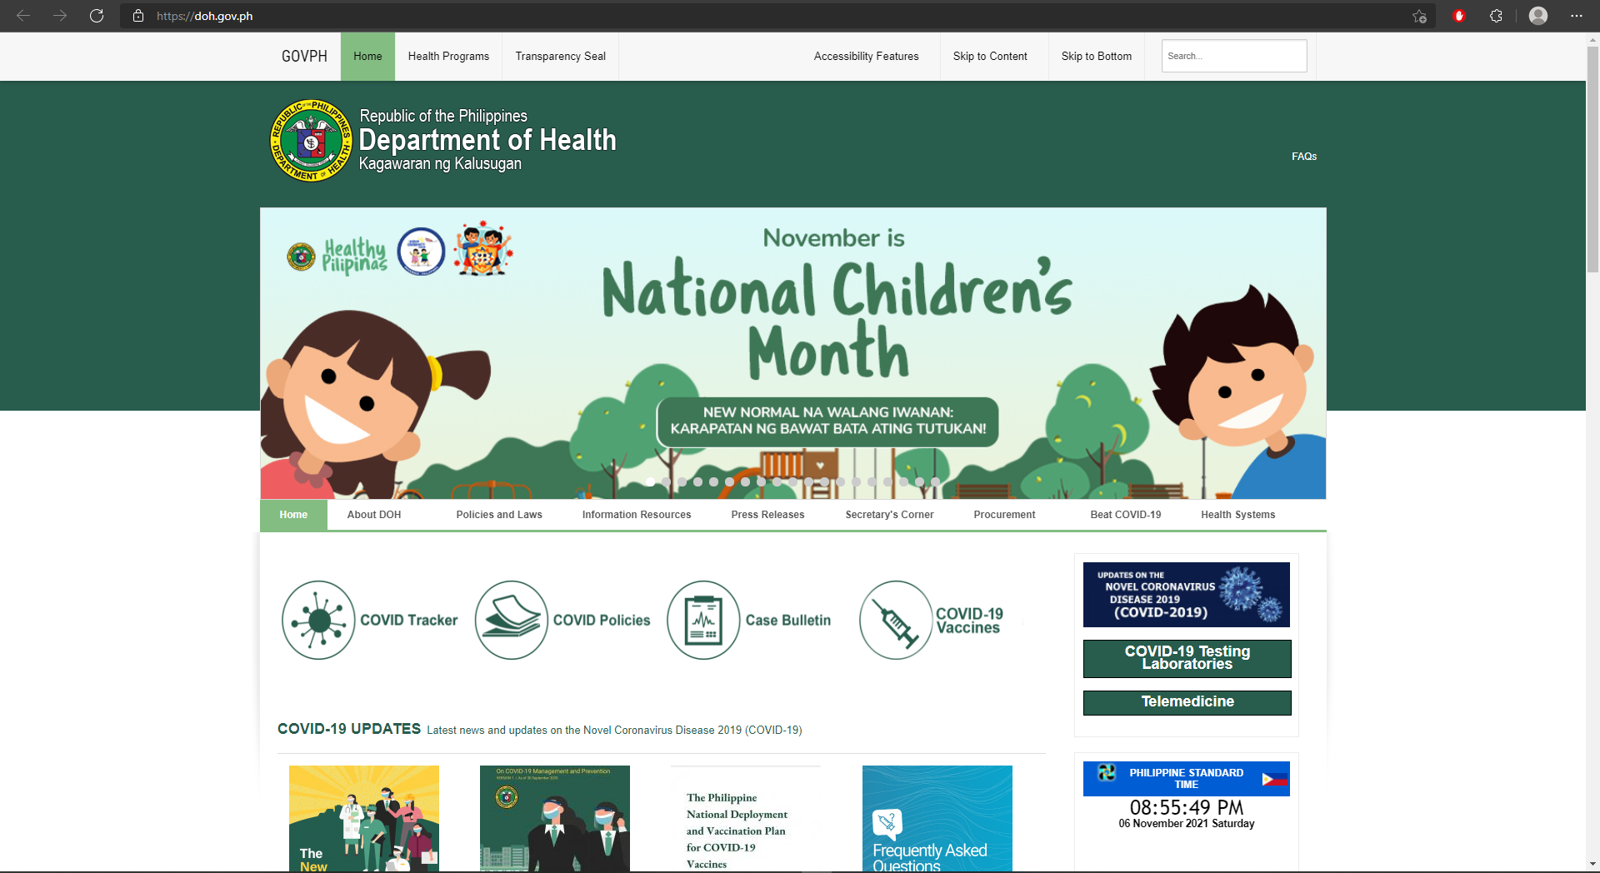

**Explanation:** This is a healthcare website in the Philippines. This website uses green as one of the colors in its palette. Green is one of the examples of color that represents health or is related to it.

1. **Shapes**

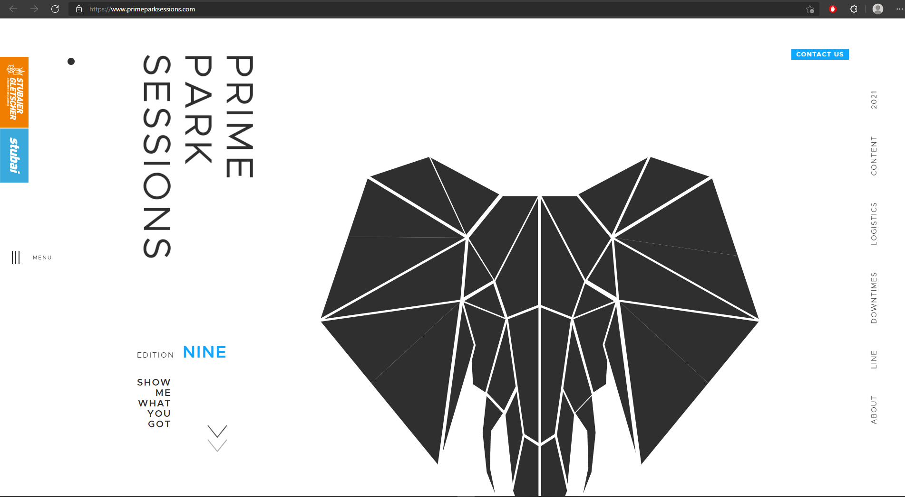

**Explanation:** This website used shapes to create an image of an elephant that is relevant and related to its topic. They used different types of shapes like triangles, rectangles, and many more.

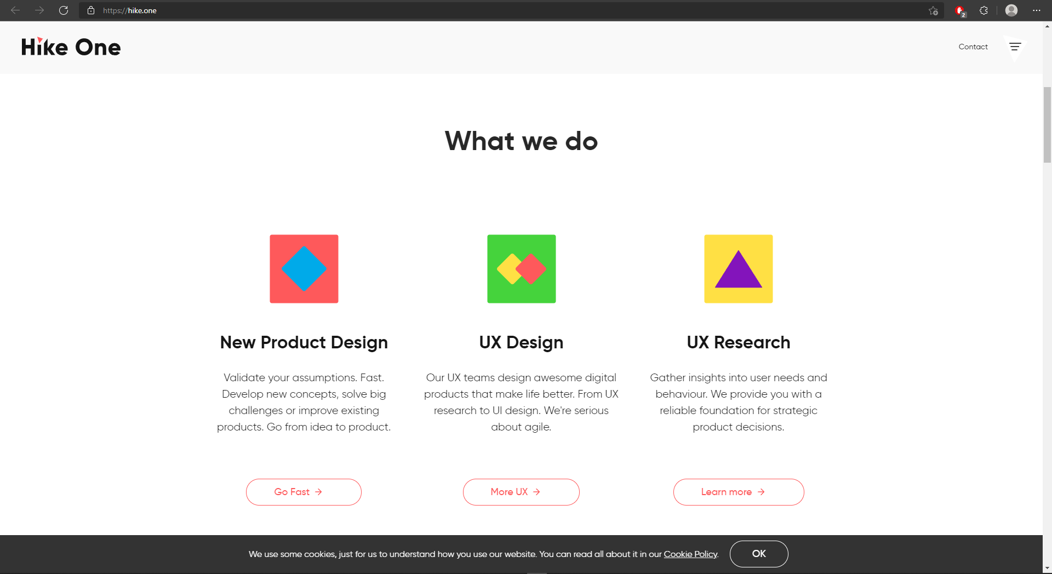

**Explanation:** This Hike One website used shapes to create an icon that will represent the idea of services they offer. They combine different kinds of shapes like squares, diamonds, and triangles. This website also uses shapes for its design.

1. **Scale**

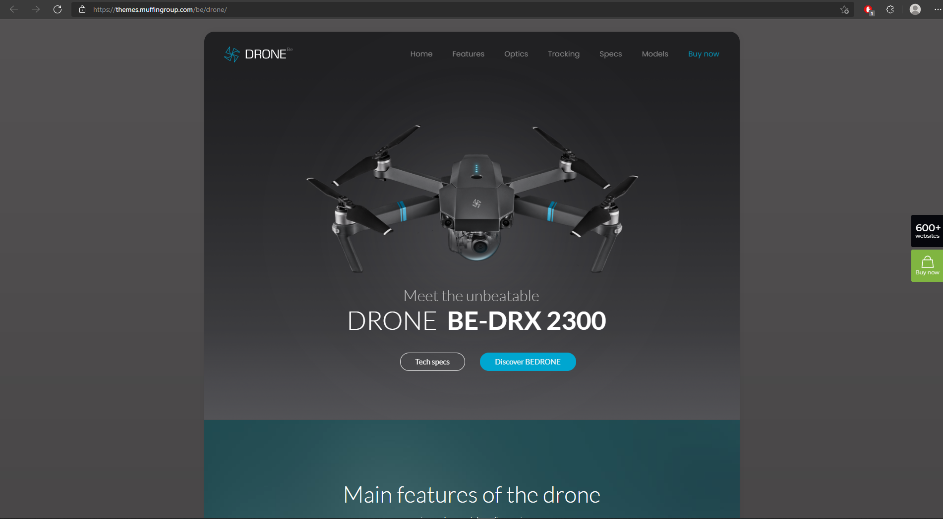

**Explanation:** This website promotes their product which is the drone. They emphasize the drone by giving it a much bigger size than other elements in the website. By doing this, the drone will quickly get the attention of the viewer.

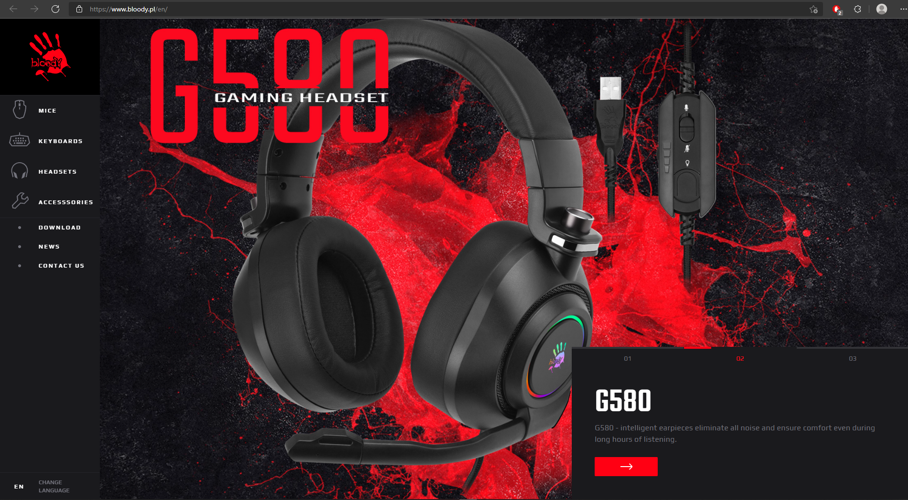

**Explanation:** This website encourages its viewers to buy and view their gaming peripherals such as headset, mouse, and keyboard. By giving the products a large scale, you can catch the viewers' attention immediately and they will be attracted to look for their products.

1. **Texture**

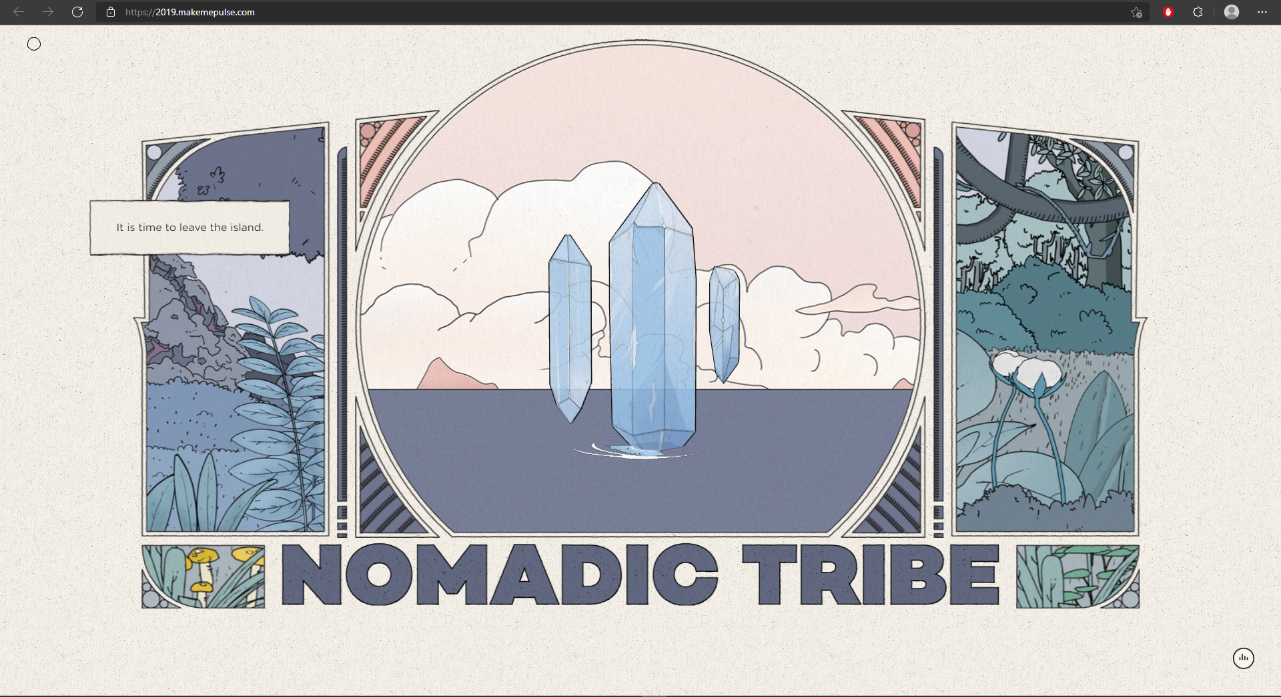

**Explanation:** This website tries to catch the attention of the viewer by making using storytelling to showcase their content. They used a background that is like a paper of a book. By doing this, they are giving texture to the website and this will also give feelings to the viewers as they are really in a storybook.

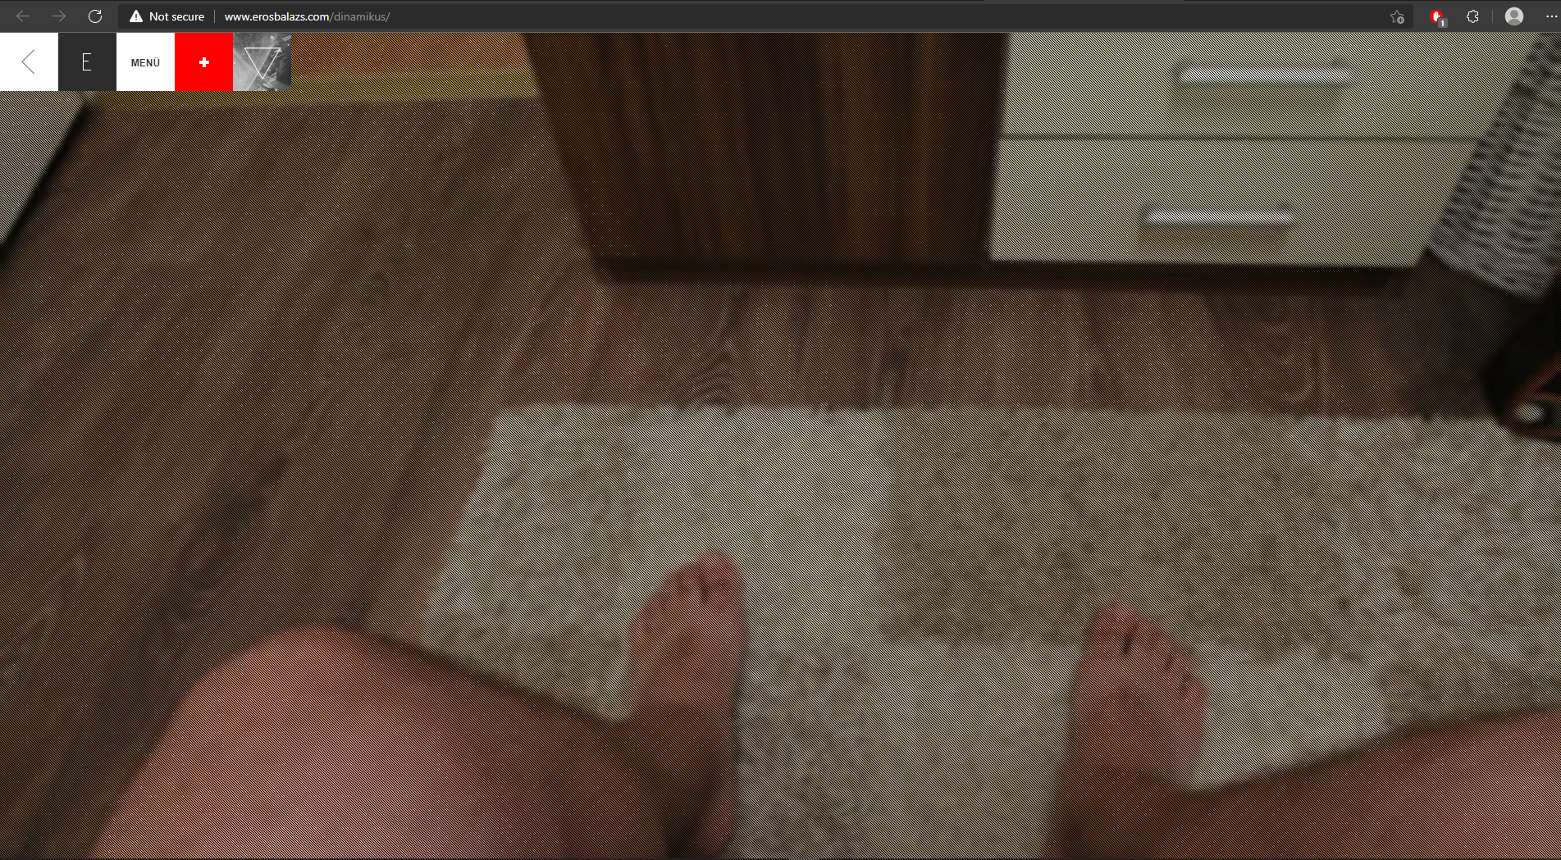

**Explanation:** This website shows the developer’s daily life from the time he wakes up until night. They add a texture that is like you are the person that is filming. By doing this, the viewers will have a perspective of what kind of life the developer is having. It’s like you are really inside the camera or the person itself. You can’t notice it much in this picture but on the website, you can feel the texture of it.

1. **Typography**

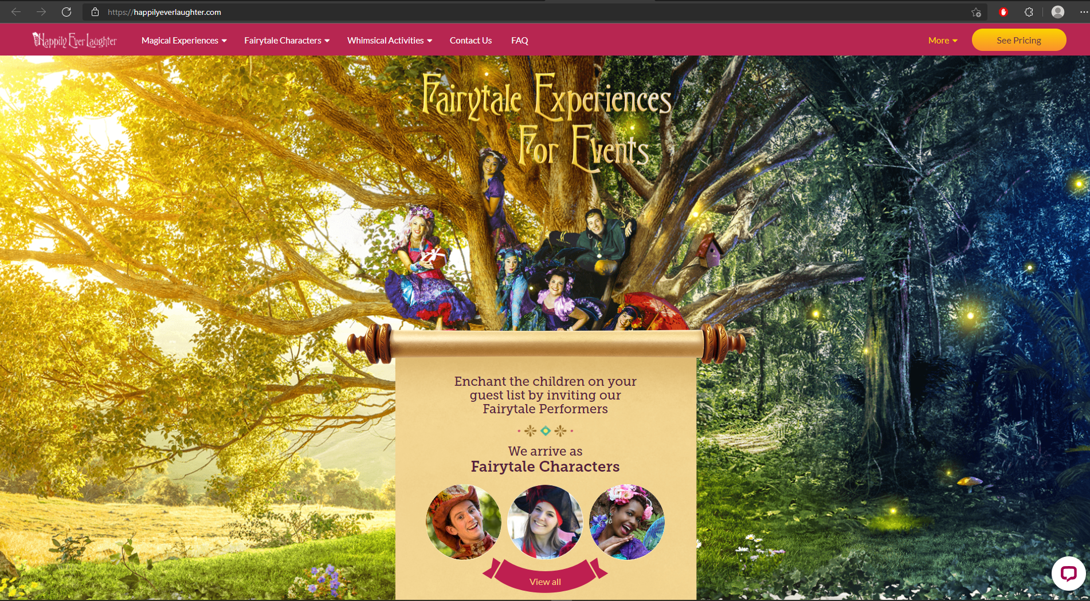

**Explanation:** This website promotes their service which is to offer a fairytale-like experience to the children. They used a font that will match their objective and their target market which is children. By doing this, the children will be excited and will interact more with the website. Imagine using fonts that are originally used for horror and thriller movies, the children will not enjoy browsing their website.

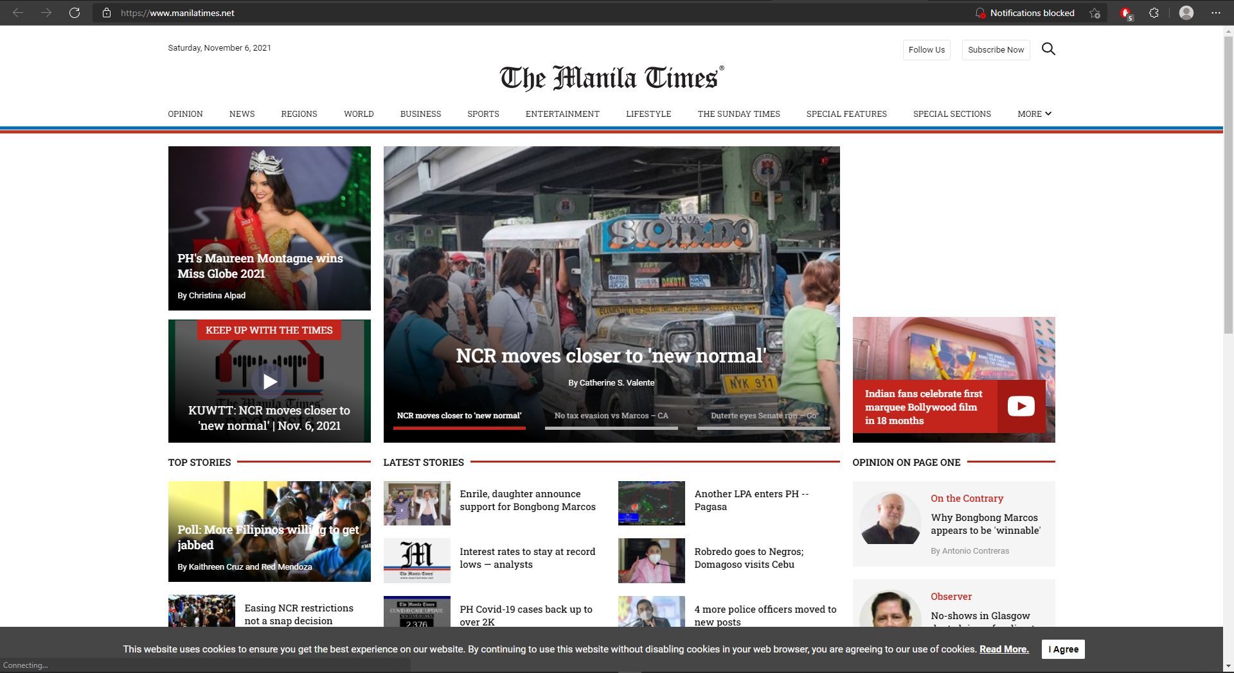

**Explanation:** This is a news website. They used a mix of serif and sans-serif for their font pairing on their website so that their content will look more serious and formal. By doing this, the viewers will feel that the news that they are giving is legit. Font pairing is very important in web design as they give formality to your website. If you use a comical font family in this kind of content, the viewers will not take the news seriously.

1. **Framing**

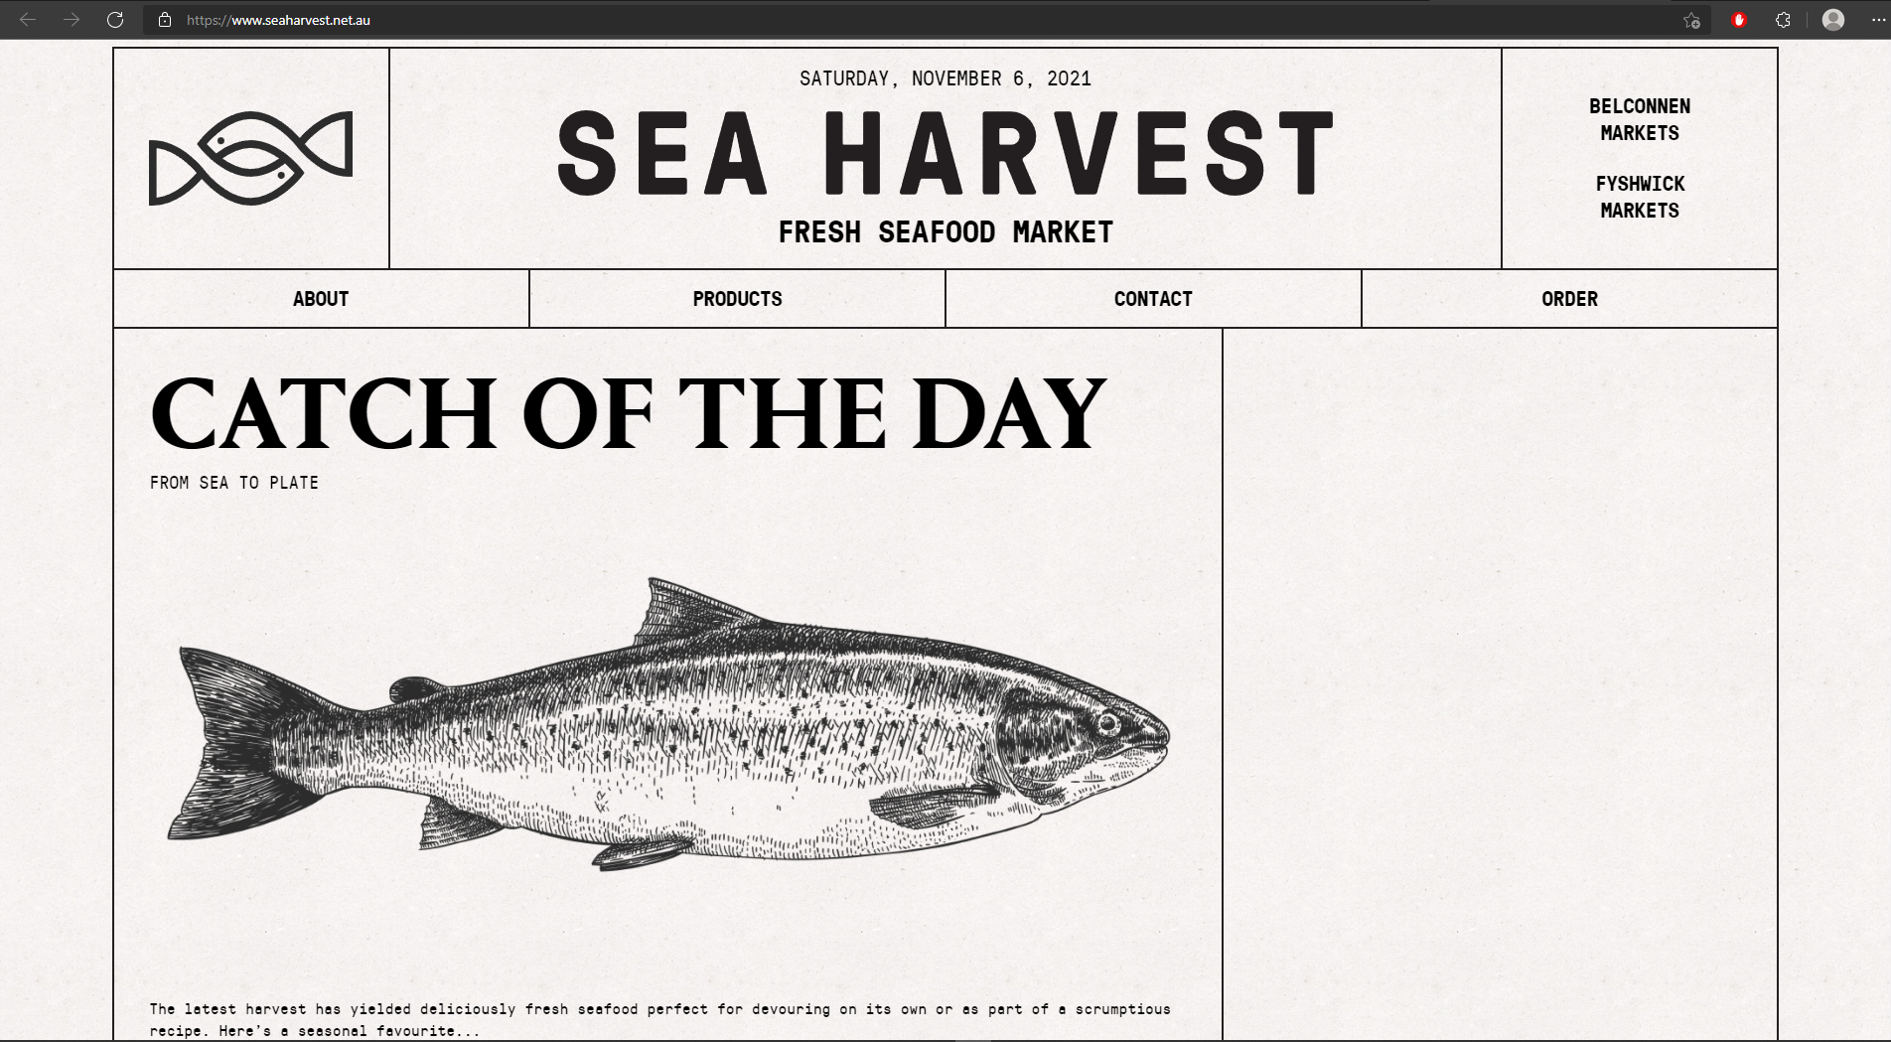

**Explanation:** This website uses lines for the framing of its headers and contents. They also frame their navigation equally. By doing this, you can easily navigate the contents because you can see the dividers for each piece of information.

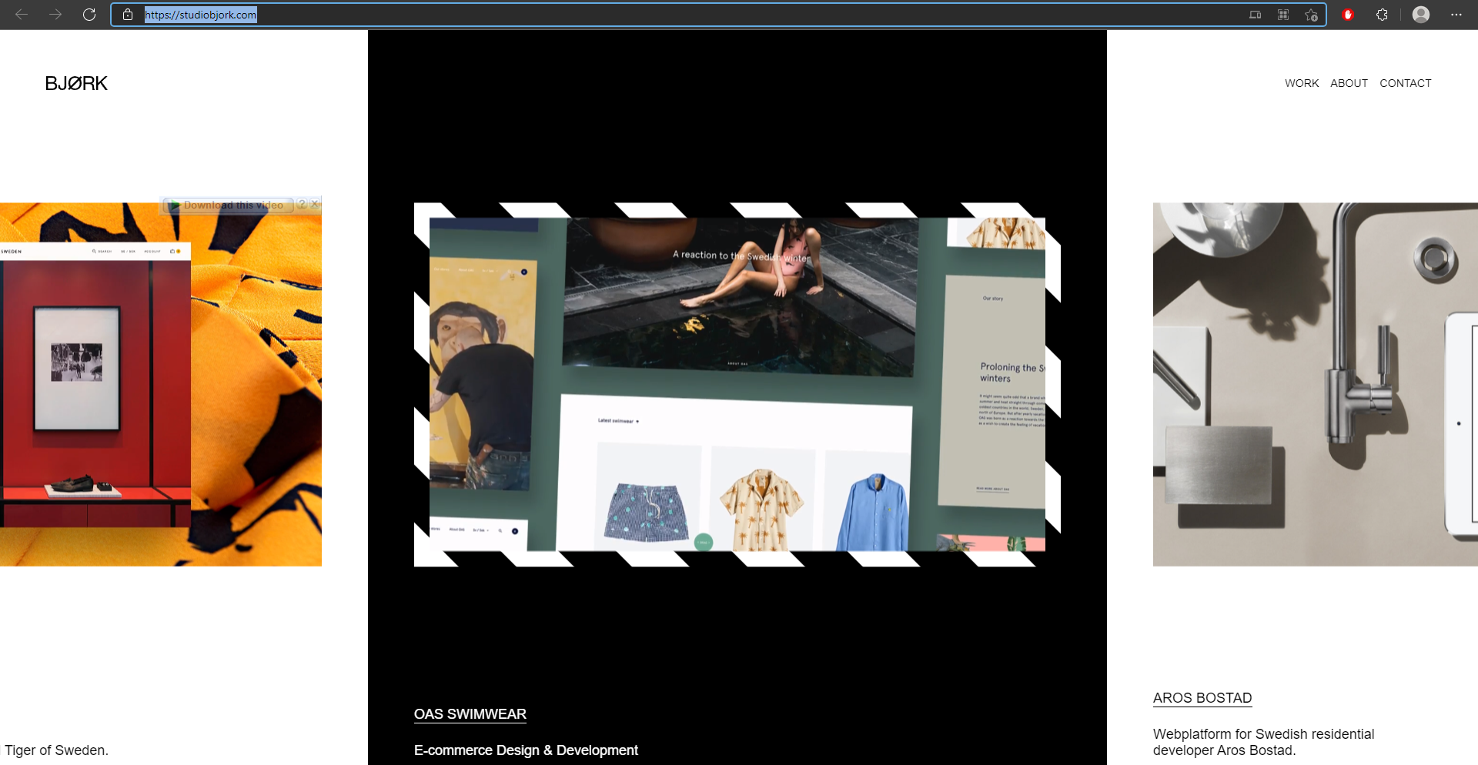

**Explanation:** This website uses an alternate black and white border to emphasize the content. By doing this, they are getting the attention of the viewers and they will look at it first.

1. **Contrast**

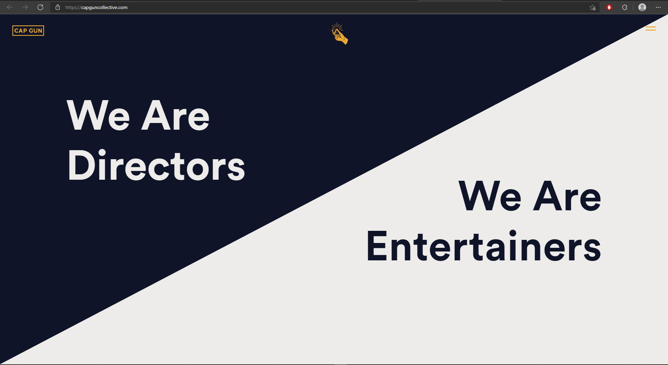

**Explanation:** This website uses this kind of contrast to show what they are. In the blue one, they said that they are directors, and on the other side they are telling that they are also entertainers. By doing this, they state their different skills and their personalities.

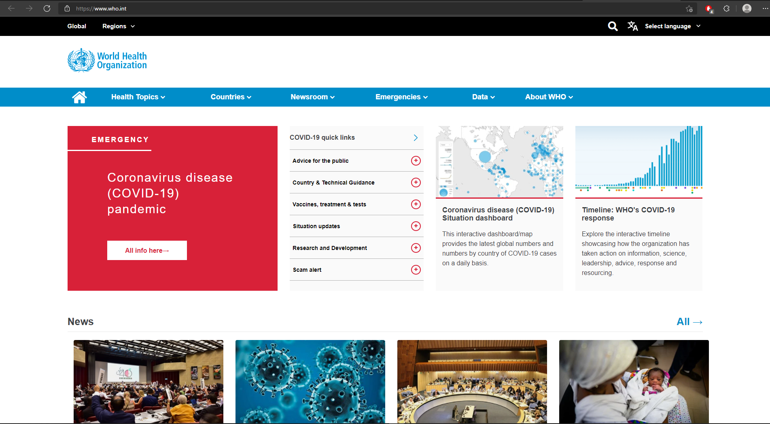

**Explanation:** This is also an example of how to use contrast in a web design. As we are experiencing a pandemic today, they give the section for coronavirus information a more contrasting color which is red. By doing this, the section on coronavirus will catch the attention of the viewers right away.

1. **Balance**

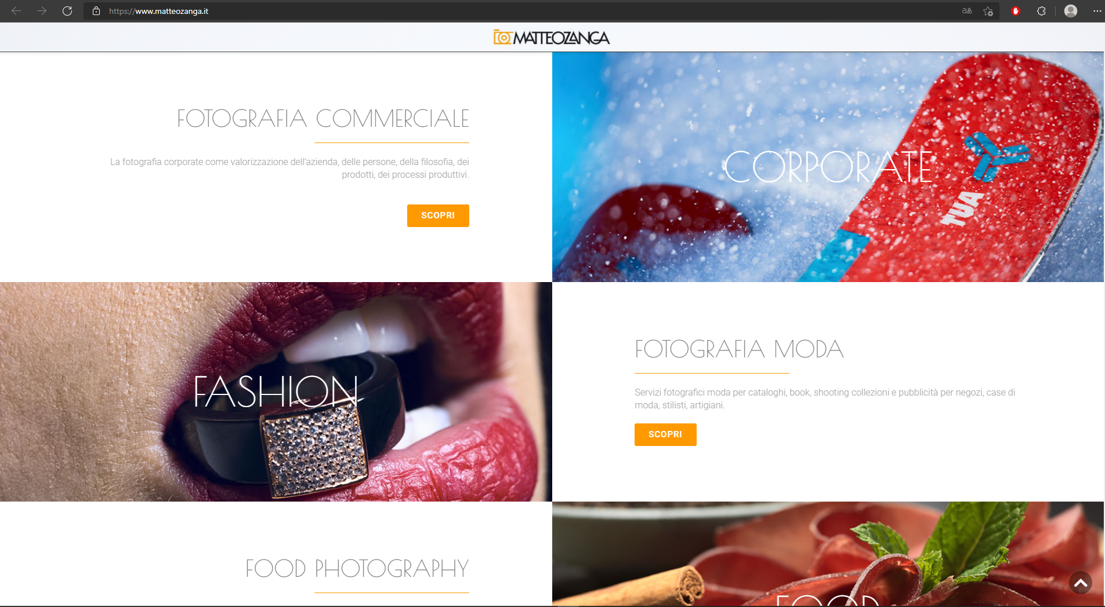

**Explanation:** This website uses a symmetrical design to show its contents. This is an example of symmetrical design because when you try to split the webpage into two, the items are symmetrical.

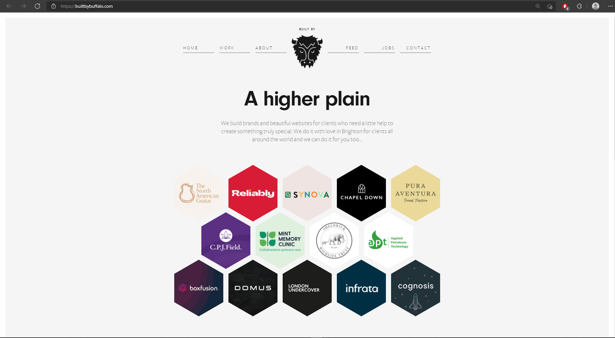

**Explanation:** This website also uses a symmetrical kind of design for its user interface. As you can see, the navigation on the left and right are equal. Also, the hexagon items below are equally distributed.

1. **Composition**

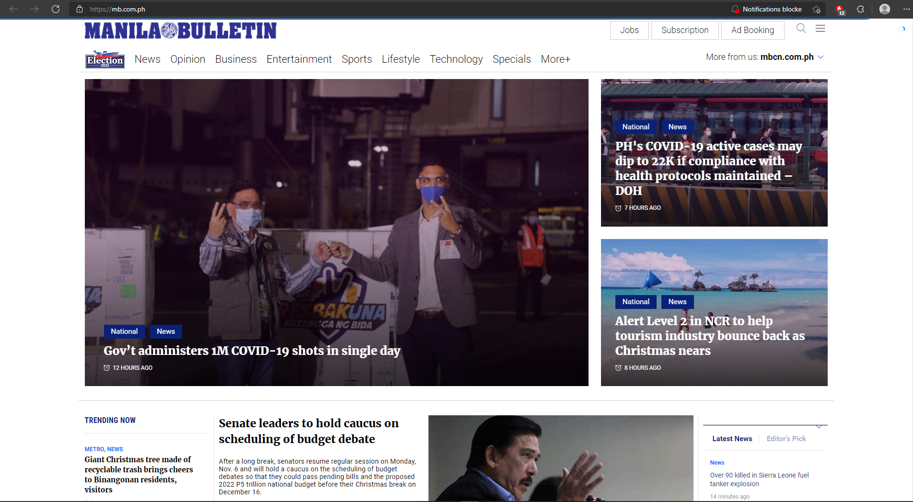

**Explanation:** This website uses composition elements in listing their news. They are giving a much larger scale to the important news and headlines. By doing this, they are giving hierarchy to their news. They are giving information to the viewers on which news is more important.

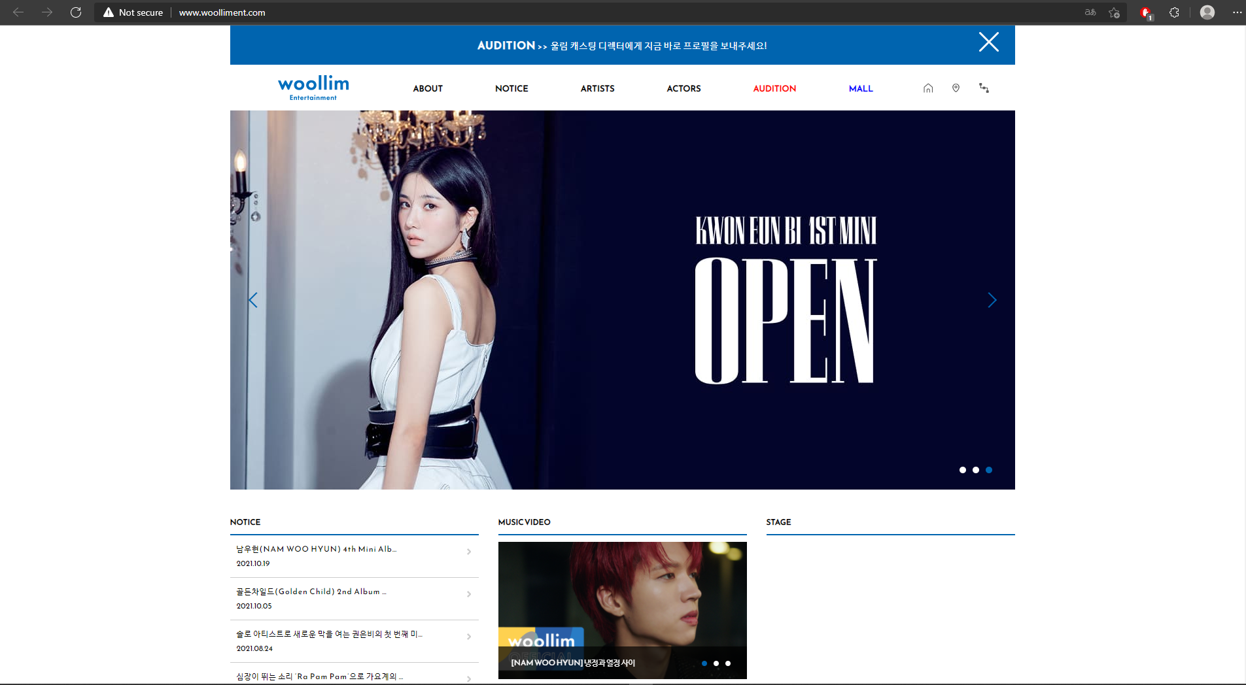

**Explanation:** In this Korean entertainment website, they also use composition elements to showcase the hierarchy of the information on their landing page. By giving a lot of space for their banner, they promote the 1st mini-album of Kwon Eunbi better and the viewers will see this first.

References:

<http://nelucebotari.com/>

<https://www.helloheco.com/>

<https://welcometoseason16.com/>

<https://doh.gov.ph/>

<https://www.primeparksessions.com/>

<https://hike.one/>

<https://themes.muffingroup.com/be/drone/>

<https://www.bloody.pl/en/>

<https://2019.makemepulse.com/>

<http://www.erosbalazs.com/dinamikus/>

<https://happilyeverlaughter.com/>

<https://www.manilatimes.net/>

<https://www.seaharvest.net.au/>

<https://studiobjork.com/>

<https://capguncollective.com/>

<https://www.who.int/>

<https://www.matteozanga.it/>

<https://builtbybuffalo.com/>

<https://mb.com.ph/>

<http://www.woolliment.com/>